**DATA BASE CONCEPTS**

**What is Database**

Ans : It is used to check the exact values which have been retrieved from the database from web or desktop applications. data should be matched correctly as per the records are stored in the database.

**What is Table ? What is Column ? What is Row?**

Ans: all the information saved or stored in the form of table and the table should have the logical, complete correct name with keys contains with unique information with no unnecessary columns

Column : we can text whether the data type is correct, size and the name should be correct, constrains should be there to restrict the invalid data in the table and the relations ship should be correct

**Example for Inner join**

Ans: To combine rows from two or more tables is called join

Selected All the rows from the table for match the columns in between the tables

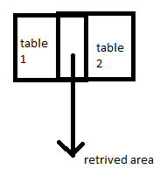

Example: select employ table to employ name

: select employ table to employ number

Department to department name

Department to department number

From employ inner join department

Emp.emp number = dep.dep number ( table name. column name)

**Example for Left outer join**

Ans :

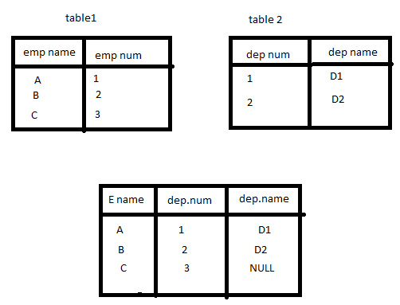

**Example for Right outer join**

Ans:

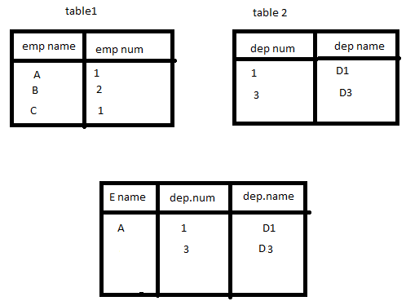

**Example for Max, sum, Avg**

Sum:

Employee

Emp. ID salary

1. 10k
2. 20k
3. 30k

$g_{sum(salary)}$**emp =60**

**Avg**: returnthe average value of n

10+20+30/3 = 60/3 = 20

$g_{Avg(salary)}$**emp =20**

Max: if there are different departments for example 1 to 10 ….so calculate maximum salary from department 2 then it considers only 2nd department people salary

$g_{Max(salary)}$**emp**

Example for Group by? Example for Having

Group by: aggregation function

${(dept)g}_{count(salary)}$**emp**

Group attribute function attribute relation

The having clause enables you to specify conditions that filters which group results appears in the final results.

**Example for Primary key**

Ans : R(ABCD) R= relation

BC A

AD B ( ABBD called as attributes)

CD B

AC D

In the table right side see which letter is missing from R relation…that is C

(C) ^+

Start combination with AC

(AC) = AC DB

(BC) =BC AD

(DC) =DC BA

These are called as candidate keys , the database takes this key and use for design purpose called as primary key

**what is stored procedure, user defined functions**

Ans: all the data will be stored in the backend function called database

Eample: if one application is created by a user and that application is connected to server , : if one application is created by using a java programming .That java programming is connected to backend database.

**Example for Foreign key**

Ans: If there are two tables containing the information regarding the some students about there performance in one table and other contain contains the name address and etc

In 1st table the student got A grade

In 2nd table should has the ID in that id grade should be contain

Then it can be recognized easily…so that is called as foreign key